Coachbuilts

2006, Fiat Ducato Autotrail Cheyenne B40SE, 2.8JTD,
PAS, 4berth, awning, tow bar, reversing camera GN06 NJO £39,995 75

2005, Ford Lexington GTS by Forest River, 6.0TD, PAS, 5 bth, auto, awnings, BX05 RBO £37,995 113

2005 (55) Fiat Ducato Bessacar E765,2.8JTD,pas,6 berth alloy wheels,1 owner, KE55 GYN £33,995 117

2006, Ford Transit Rimor Super Brig 677, LHD, 6 bth, PAS, 2.5TDCI garage, YN56 ALU £32,995 76

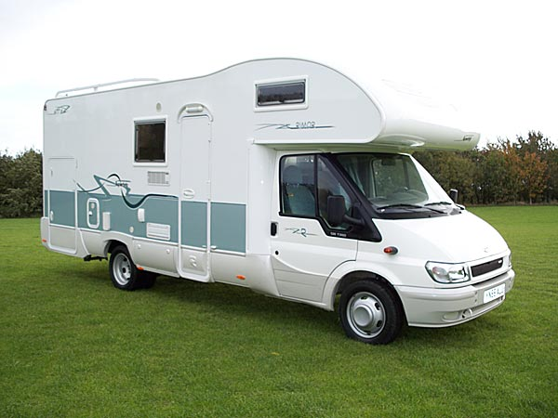
Ford Transit Rimor Super Brig 677

2009 New model Ford Transit Home car XS22, 2.2TDCI, PAS, 2 berth , Heki roof light £31,995 86

2006(06) Renault Master Cipro 85 Top Class DCI 120,2.5TD,pas,3 berth,awning,rev cam,2 single fixed beds,heki roof light,oven grill hob,fridge, SV56 BKY £29,995 120

2008 (08) Peugeot Boxer Elddis Firestorm 140 2.2 M’jet,4 berth,awning,tow bar, GN08 GUA £27,995 33

2003 (03) Fiat Ducato Bessacar E765,2.8TD,pas,6 berth,awning,fixed bed, BU03 JJL £27,995 66

2005, Mercedes CI Cipro 55, 2.7TD, PAS, 4 bth, cab aircon. c rack, tow bar, rev cam, S1 ATO £26,995 91

2004, Fiat Ducato Benimar Anthus 6000ST, 2.8JTD, PAS, 6 berth, FJ04 MSV £26,995 62

2007, Fiat Ducato Lunar Champ A551, 2.0TD, PAS, 4 berth, cycle rack, FX56 JXJ £24,995 71

2003, Fiat Ducato Ace Novella Roma, 2.8TD, PAS, 6 berth, awning, garage, YW52 LGJ £23,995 95

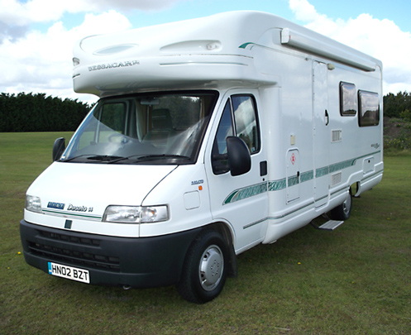
Fiat Ducato Bessacarr

2003, Fiat Ducato Bessecarr E450, 2.3JTd, PAS, 2 berth, cycle rack, HX53 VBP £23,995 8

2003, Fiat Ducato Ci Riviera 181, 2.8TD, PAS, 6 berth, awning, cycle rack, AU03 OHF £22,995 72

2003, Fiat Ducato Benimar Anthus 6000ST, 2.8TD, PAS, 6 berth, tow bar, FJ03 TWD £22,995 34

2003, Fiat Ducato Ace Novella Milano, 2.0HDi, PAS, 5 bth, awning, c rack, KX03 VFV £22,995 92

2002, Fiat Ducato Elnagh Marlin Garage, 2.8JTD, PAS, 6 berth, FN02 RDU £22,995 57

2000, Fiat Ducato Hobby 700, 2.8TD, PAS, LHD, W746 STA, 4 berth, air con, swivel seats,
was £24,995 – now £22,995 51

2005, Fiat Ducato Ci Carioca 635, 2.3JTd, PAS, 5 berth, OU05 LWE, £22,995 43

2003(03) Ford Transit Autosleeper Duetto, 2.5TD,pas, 2 berth,awning,cycle rack.NX03 KXT £22,995 111

2004 (54) Fiat Ducato Swift Suntor 590RS,2.3JTD,pas, 5 berth,Suntor pack, A16 MWH £22,995 12

2004(54) Fiat Ducato Burstner T585,2.3jtd,pas,3 berth awning,rev cam,towbar,c rck AU54 EWP £22,995 114

2006, Ford Transit Rimor Katamarano, 2.5TD, PAS, 6 bth, cycle rack, awn,YX06 NGJ £22,995 50

1999, Fiat Ducato Swift Kon Tiki 650, 2.8idTD, 5 berth, cycle rack, T116 ERA £22,995 24

2003(03) Fiat Ducato knaus sun traveller 2.3JTD,pas,4 berth,awning,roof/ladder rack, FJ03 AKF £22,995 18

2000, Fiat Ducato Bessacarr E765, 2.8JTD, PAS, 6 bth, awn, air con, W342 TNG £22,995 28

2004, Fiat Adriatik Coral 650, 2.8TD, PAS, LHD, 4 berth, cycle rack, awn, Y2 PML £21,995 6

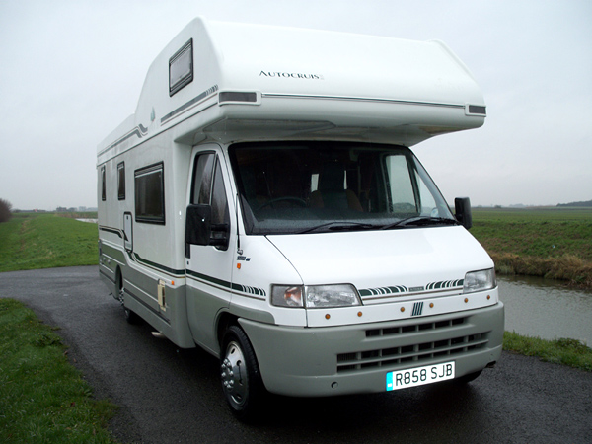
Fiat Ducato Autocruise Impala 5ET

2001, Peugeot Boxer Wentworth, 2.8TD, PAS, 2 berth, tow bar, HX51 HFW £21,995 115

2005, Fiat Ahorn Camp, TD, PAS, Roof rack, ladder, cycle rack MX05 TXC £21,995 67

2000, Fiat Ducato Autotrail Cherokee, 2.8TD, PAS, 4 berth, awning, c rack, X989 NVW £20,995 21

2003, Fiat Ducato Eura Mobil, 2.3JTD, PAS, 4 berth, cycle rack, BU03 FZV £19,995 47

1997, Fiat Ducato Autocruise Impala 5ET, 2.5TD, PAS, 5 berth, awn, tow, R858 SJB £19,995 108

1997, Fiat Swift Kontiki 640 2.5TD, PAS, 5 berth, ladder, roof bars, awn, c/rack (899 VG 79)
R366 YBK £19,995 77

1999, Peugeot Boxer Autostratus, 2.4TD, PAS, 6 berth, awning, cycle rack, T210 JFP £18,995 93

1999, Peugeot Boxer Autostratus EB, 2.4TD, PAS, 6 berth, awning, cycle rack, T788 VNU £18,995

2002, Peugeot Boxer Vivanti4, 1.9TD, PAS, 4 berth, cycle rack, HN02 DHM £18,995 78

1995, Fiat Ducato Autocruise Chamois ED, 2.5Tdi, PAS M116 EFK, 4 berth £18,995 45

2000 Fiat Ducato Autotrail Cheyenne 590SE 2.8TD,pas 4 berth, awning W288 UGU £18,995 105

2005 (05) Fiat Ducato Coachbuilt M’home 2.8JTD,pas,4 berth,awning,cycle rack YY54 VXW £17,995 2

2000(X)Fiat Ducato Swift Lifestyle 590RL,2.8D,PAS,4 berth,awning,c/rack,tv aerial X246 NBP £17,995 118

2003, Fiat Ducato McLouis 410, 2.0TD, PAS, 5 berth, awning, cycle rack, FM03 PBF £17,995 59

2001, Peugeot Boxer Autohomes Wanderer, 1.9TD, PAS, 4 berth, c rack, awn, Y731 FYA £17,995 110

1998, Ford Transit Autosleeper, 2.5TD, PAS, 2 berth, awning, tow bar, R113 GFM £17,995 90

2000, Fiat Ducato Swift Suntor Millennium 590 RS, 2.8D, PAS, 4 bth, awn, W132 PTO £17,995 5

1998, Peugeot Boxer Autostratus SE, 2.4TD, PAS, 4/5 berth, awn, tow bar, R10 HSU £17,995 109

1998, Fiat Ducato Autotrail Cheyenne, 2.5TD, PAS, 5 berth, awning, S828 LRA £17,995 52

1998, (R) Fiat Ducato Bessacar E600, 2.5D, PAS, 5 berth, air blown heating, c/rack R663 EWX £17,995 3

1997, Peugeot Boxer Swift Royale 610, 2.5TD, PAS, 4 berth, awn, tow bar, R610 SJW £16,995 26

1999, Peugeot Boxer Autohomes Windfall, 1.9TD, PAS, 4 berth, awning, V228 DHN £16,995 63

1998, Peugeot Boxer Autohomes Wayfarer, 1.9Td, 5 berth, awning, R814 NRR £16,995 87

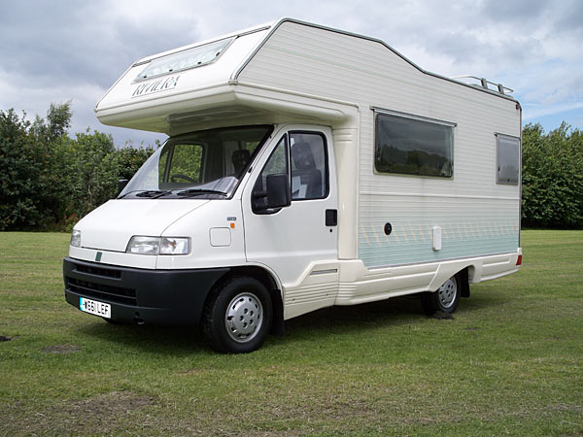
Fiat Ducato Ci Riviera 570

2000, Fiat Ducato Ci Riviera 570, 1.9TD, PAS, 5 berth, W661 LEF £16,995 100

1997, Fiat Ducato Autocruise Starfire, 1.9TD, PAS, 2 berth, awning, c rack, R558 WTP £16,995 19

2000, Ford Transit Karmann 190LWB, 2.5TD, 4 berth, PAS, c rack, awn, W311 MBJ £16,995 13

2001, Peugeot Boxer Avantgarde 100, 1.9TD, PAS, 4 berth, SP51 EWE £15,995 16

1998, Fiat Ducato Autotrail Pawnee, 1.9TD, PAS, 4 berth, R808 FOW £15,995 74

1999, Fiat Ducato Autotrail Pawnee, 1.9TD, PAS, 2 berth, awning, towbar, T169 RVA £15,995 121

1994 (M) Ford Transit Autosleeper Amethyst 2.5D;pas,Automatic,2 berth M878 THL £15,995 119

2000, Fiat Ducato Granduca, 2.8TD, PAS, LHD, 5/6 bth, c rack, awn, tow bar, Y812 RVY £15,995 88

1999, Fiat Ducato Swift Suntor 520, 1.9TD, PAS, 4 berth, awning, T182 ERA £15,995 58

1996, Fiat Ducato Autotrail Cheyenne 584, 2.5D, PAS, 4 berth, c rack, awn, N895 LRT £15,995 17

2000, Fiat Ducato Elnagh Marlin Slim 2, 1.9D, PAS, 4 berth, X643 WRB, £15,995 22

1996, Fiat Ducato Autotrail Cheyenne, 2.5TDI, PAS, 2berth, awn, c rack, N703 ARA £14,995 15

1996 Peugeot Boxer Eldiss Autoquest 3505. PAS, 4 berth, awning, c/rack N512 YRB £14,995 53

1995, Fiat Classic FFB 580, 2.5D, PAS, 4 berth, awning, M817 YWE £14,995 60

1996, Chevrolet Conquest by Gulf Stream, 6.5D, 4 berth, auto, N316 UOA £14,995 46

1995, Ford Transit Meridien Ci Urbano, 2.2TD,
PAS, 4 bth, awn, c rack, (C4 MFS) M792 MVV £13,995 96

1990, Fiat TurboD Hymer, PAS, 6 berth, awning, ladder, tow bar. H852 BHG £12,995 106

1990, Talbo Express Hymer, LHD, PAS, 6 berth, awning, top box. H352 JLF £12,995 123

1992, Talbot Express Pilote Galaxy 78MX, 2.5TD, PAS, 5 bth, awn, K192 EUX £12,995 94

1994(L) Ford Transit Herald Aragon 2.2TD,pas, 2 berthroof/ladder rack. L709 GCX £11,995 103

1997, Fiat Ducato Riva Mobil City 490, 1.9D, 4 berth, cycle rack/box, P626 JBC £11,995 40

1991, Fiat Ducato Compass Calypso, 1.9TD, 2 berth, awning, H986 BGW £10,995 30

1990, Fiat Ducato Hymer, 2.5D, LHD, PAS, 4 berth, awn, c rack, tow bar, G717 BGS £10,995 82

1993, Talbot Express Autotrail Cheyenne SE, 2.5D, 5 berth, awning, L283 PDU £9,995 4

1990, Citroen Hymer Camp 2.5TD, LHD, 4 berth, cycle rack, G959 AVL £8,995 44

1989, Mercedes Pioneer 310D, 2.4D, ladder, TV point, 4 berth, F376 AVG £7,995 56

1986, VW LT Motorhome, 2.4 petrol, 6 berth, awning, C53 VHA £7,995 65

Hi Tops

2007 (57) Fiat Ducato Moncayo 120 M’jet,2,2TD,pas,2+1 berth,awning FX57 NNL £25,995 89

2003, Ford Transit Duetto Autosleeper, 2.4TD, PAS, auto, 2 bth, awn, c rack, DA03 RYB £22,995 116

1997, Peugeot Boxer Cockburn Holdsworth, 2.4D, PAS, 2 berth, P608 OVX £16,995 7

1998, Peugeot Boxer Autosleeper Symphony, 2.0 pet, PAS, 2 berth, R754 PVN £15,995 32

2005, Citroen Relay Van Conversion, 2.2TD, PAS, 2 berth, SD55 XVU £14,995 97

1999, Fiat Itaca Ci Europe, 1.9TD, PAS, 2 berth, rev camera, T136 SCH £14,995 98

2001, Citroen Relay Leisuredrive, 2.5D, PAS, 2 berth, cycle rack, Y139 NBN £14,995 35

1997, Fiat Ducato Mondial Lifestyle, 2.0 petrol, PAS, 2 berth, c rack, P158 MTP £14,995 11

2002, Toyota Hi-Ace 300GS, 2.5TD, PAS, 2 berth, YK52 CJO £14,995 31

1995, Peugeot Boxer Holdsworth Tempo, 2.5D, 2 berth, ladder, roof rack, N655 LCD £14,995 36

1996, Ford Transit Duetto Autosleeper, 2.5D, PAS, 2 berth, N799 EYC £14,995 10

1995, Ford Transit Duetto Asleeper, 2.5D, PAS, 2 bth, awn, c rack, tow bar, N578 XRA £13,995 39

1994, Ford Transit Duetto Autosleeper, 2.5D, PAS, 2 bth, awning, tow bar, M396 GDV £13,995 85

1995, Ford Omega Autosleeper, 2.5D, 2+2, awning, M621 XSL, £12,995 37

2001, Vauxhall Movano Van Conversion, 2.2D, 2 berth, cycle rack, Y691 VEF £12,995 9

1996, VW Transporter, 1.9L, PAS, 2 berth, elevating roof, N187 BDC £12,995 122

1998, Citroen Romahome, 1.8D, PAS, 2 berth, R825 FDL £11,995 42

1994, Talbot Express Autotrail Badger, 2.0 petrol, 2 berth, cycle rack, M901 YPW £11,995 38

1994, Talbot Express A.sleeper Harmony, 2.0 pet, 2+2 bth, PAS, M948 HRU (FRM 111) £9,995 1

1997, Ford Transit JC Leisure Conversion, 2.5D, 2 berth, P173 UGT £9,995 69

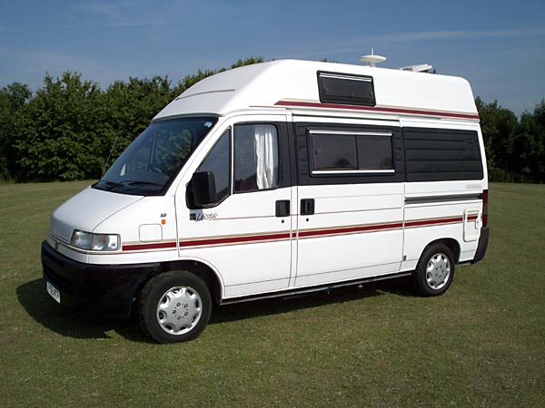
Fiat Ducato Mondial Lifestyle

1992, Talbot Express Autohomes Avalon, 2.0 petrol/gas, 2 berth, awn, K285 XFL £8,995 14
1994, Talbot Express Autotrail Badger, 1.9D, 2 berth, cycle rack, M638 XPW £8,995 54
1993, Talbot Express Autosleeper Rambler GL, 1.9 petrol, 2 berth, c rack, L989 NAL £8,995 104
2004, Suzuki Carry Drivelodge Bijou, 1.3 petrol, 2 berth, PAS, FY54 ZHA £8,995 29

1996, Iveco Sunseeker, 2.8JTD, PAS, 2 berth, awning, P634 JKP £8,995 81

1998, Mazda Bongo Friendee, 2.5TD, PAS, automatic, lift-up roof, R356 GJL £8,995 8

1992, Renault Traffic Eriba Car, D, awning, towbar, K56 SLF £8,995 79

1992, Talbot Express Autohomes Avalon, 2.0 petrol, J297 ENN £7,995 20

1990, Renault Traffic Rimini, 1.7 petrol, 2 berth, lift-up roof, G919 FLJ £7,995 55

1987, Talbot Express Autosleeper Talisman II, 1.9 pet, 4 bth, awn, tow bar, D851 RTM £7,995 41

1996, VW Overlander LT35, 2.4D, PAS, 2 berth, N495 EDT £6,995 83
1989, Talbot Express Autohomes Camelot, 2.0 petrol, 2+2, awning, F223 KDM £6,995 27
1992, Talbot Express Holdsworth Topic, 2.0 petrol, 2 berth, J374 VPY £6,995 101
1997, Renault Trafic Van Conversion, 2.0D,PAS,2 berth, P276 EAW £6,995 25
1987, Talbot Express Camelot, 1.9 petrol, 2+2, E806 DPG £4,995 49

1993, Mazda Reimo E2000, 2.0 petrol, 2 berth, L991 LWU £4,995 102

1989, Talbot Express O’Leary, 1.9D, 2 berth, awning, cycle rack, G666 HKY £3,995 23

1997, Mazda Bongo Friendee, 2.5D, 8 seat people carrier, P377 RNE £3,995 48

American Motorhomes

2005, Ford Lexington GTS by Forest River, 6.0TD, PAS, 5 bth, auto, awns, BX05 RBO £37,995 113

1996, Chevrolet Conquest by Gulf Stream, 6.5D, 4 berth, N316 UOA, Automatic £14,995 46

3rd March 2010 E&OE

Whilst care is taken to make sure that all relevant information is present and correct there may still be errors in this brochure. If you find an error or omission, please let us know, and we will correct it as soon as possible.

